## Abstract

#### Tittle : ExamPro - Exam Cell Automation

The admission or registration process of college is necessary on periodic basis in every educa- tional institution. It should be accurate and less bulky. This manual process of student registra- tion and result generation is always bulky and tedious. All these problems can be eliminated if the college system is automated. By automating this system, the examination coordinators can easily conduct the registration of students and the generation of results systematically. The sys- tem is an efficient, decisive resource for institutions and students. It will help at different levels for bringing reliability, efficiency, scalability, transparency and robust solutions. So an attempt has been made to make it easy for exam cell staff as well as the students.

**CHAPTER 1**

**INTRODUCTION**

## Introduction

Most of the important processes in the institutes are carried out manually such as the registration of the students, managing huge information about students, faculty members i.e. the teaching and non-teaching staff, managing documents for different entities which leads to enormous bulk of work. This results in poor efficiency, lots of documentation which again leads to unmanage- able data, tedious process and requires a lot of time and human resource.

The main goal of the Exam Cell Automation System is to minimize these workloads and make the Exam Cell process much more convenient to follow. The Exam Cell processes include the managing of student’s academic status distinguished by the year, the departments, the classes as well as with respect to subjects. The Exam Cell process also includes Exam Time Table, the generation of exam forms etc. These all processes are carried out either manually or with the help of some third party software. The use of multiple software for carrying out a process is never considered efficient.

### Motivation

The current examination process system is a complete manual work system which results in tedious work. It is necessary to manage registrations and admissions of students in periodic time at the educational institutes. The current system deals with the manual entries of the in- formation about the students which leads the system prone to errors. The errors which might occur are the loss of data, data redundancy, time consuming process etc.

The current system needs a lot of labour work as all the activities are done manually. The current system not only increases the workload for the exam-cell staff members managing the registration. The collection of Exam Time Table, Schedule of Exam Time Table becomes a complicated and bulky process. Managing hard copies stack by stack becomes a tedious work for the exam-cell staff.

## Problem Definition

This project consists of several modules which are used in the exam cell process. The project represents an automated system which ensures the reduction of the tediousness, more effective work and systematic management. The project deals with the registration of students, the faculty members. This project aims to bring in a centralized system that will ensure the tasks and activities related with the examination can be effectively managed. The system allows the student to register themselves into the system, they can view academic status on the system. This project will provide an easy and efficient way for the processes to be automated which will reduce the workload of the exam cell staff by heavy extent.

## The Problems with Current System

The current systems are traditional systems which support manual processes leading to huge time consumption and stack of hard copies. The systems make the processes delayed and more prone to errors as the work is performed by hand. The institutes need to pay huge amount for these systems every year, which then generates the New Schedules for Exam Time Table. However, the systems do not provide all the functionality required by the institutes.

## Goals and Objectives

Currently the Exam cell activities includes a lot of manual calculations and are mostly paper based. This makes the process tiresome. This project aims to bring in a centralized system that will ensure the tasks and activities related with the examination can be effectively managed. The system allows the student to register themselves into the system, they can view their academic status on the system. The project will provide an easy and efficient way for the processes to be automated which will reduce the workload of the exam cell staff by a heavy extent.

## Scope and Applications

The scope of the project is: All the examination related work for the students can be done using this system. It will provide faster and easier access for updating records as the paper work will reduce. All the students related database can be retrieved at any time by authorized personnel. Application support and maintenance after deployment will be provided to production. The System can be customized as per the requirements of the college.

# CHAPTER 2

# SYSTEM SPECIFICATION

## System Features

### PHP

PHP is a server-side scripting language designed primarily for web development but also used as a general-purpose programming language. Originally created by Rasmus Lerdorf in 1994, the PHP reference implementation is now produced by The PHP Development Team. PHP originally stood for Personal Home Page, but it now stands for the recursive acronym PHP: Hypertext Preprocessor.

### MySQL

MySQL is an open-source relational database management system (RDBMS). Its name is a combination of "My", the name of co-founder Michael Widenius’ daughter, and "SQL", the abbreviation for Structured Query Language. The MySQL development project has made its source code available under the terms of the GNU General Public License, as well as under a variety of proprietary agreements. MySQL was owned and sponsored by a single for-profit firm, the Swedish company MySQL AB, now owned by Oracle Corporation. For proprietary use, several paid editions are available, and offer additional functionality.

### Bootstrap

Bootstrap is a free and open-source front-end web framework for designing websites and web applications. It contains HTML- and CSS-based design templates for typography, forms, but- tons, navigation and other interface components, as well as optional JavaScript extensions. Un- like many web frameworks, it concerns itself with front-end development only. Bootstrap is the second most-starred project on GitHub, with more than 107,000 stars and 48,000 forks.

### Dia

Dia has a modular design with several shape packages available for different needs: flowchart, network diagrams, circuit diagrams, and more. It does not restrict symbols and connectors from various categories from being placed together. Dia has special objects to help draw entity- relationship models (obsoleted tedia2sql or newer parsediasql can be used to create the SQL DDL), Unified Modeling Language (UML) diagrams, flowcharts, network diagrams, and simple electrical circuits. It is also possible to add support for new shapes by writing simple XML files, using a subset of Scalable Vector Graphics (SVG) to draw the shape.

Dia loads and saves diagrams in a custom XML format which is, by default, gzipped to save space. It can print large diagrams spanning multiple pages and can also be scripted using the Python programming language.

## System Requirement :

### Supportive Operating Systems :

The supported Operating Systems for client include: Linux, Windows, Mac OS

## Software Requirement :

The Software Requirements in this project include:

#### XAMPP:

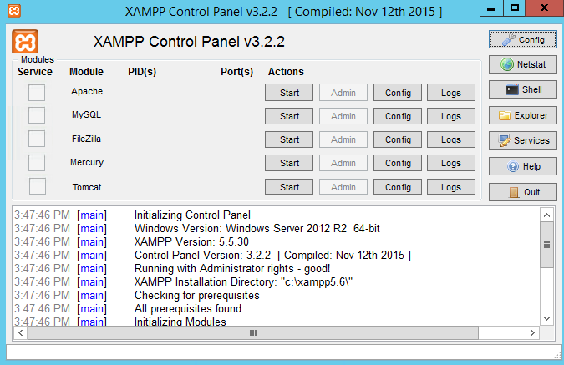

Figure 2.1: XAMPP

XAMPP is a free and open source cross-platform web server solution stack package developed by Apache Friends, consisting mainly of the Apache HTTP Server, MariaDB database, and interpreters for scripts written in the PHP and Perl programming languages.

#### Web Browser:



Figure 2.2: Web Browser

A web browser (commonly referred to as a browser) is a software application for retrieving, presenting and traversing information resources on the World Wide Web.

#### MySQL:



Figure 2.3: MySQL Logo

MySQL is an open-source relational database management system (RDBMS). Its name is a combination of "My", the name of co-founder Michael Widenius’ daughter, and "SQL", the abbreviation for Structured Query Language.

## Hardware Requirement :

#### Computer(Device):



Figure 3.4: Computer

A computer or a device is needed to run the developed system.

#### RAM:

RAM should be above 2 GB.

#### Processor:

32 bit/ 64 bit processors are supported.

# Chapter 3

**SYSTEM DESIGN**

## System Architecture

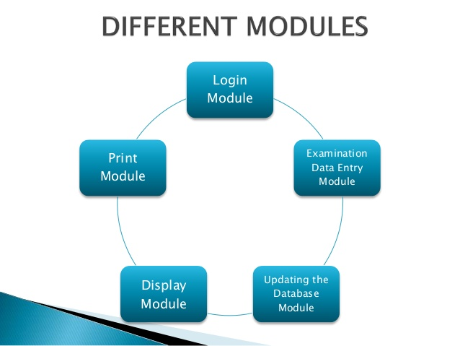

Figure 3.1: System Architecture

## Usecase Diagram

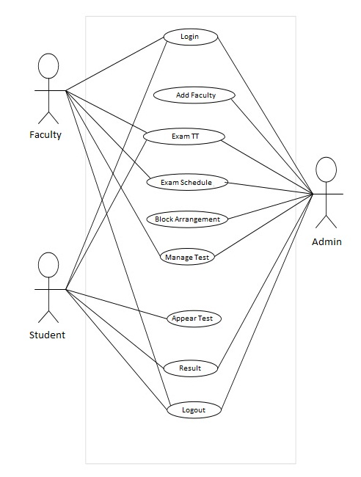

Figure 3.2: Usecase

### Usecase Report

|  |  |
| --- | --- |
| Title | Exam cell Process Automation |
| Description | ExamCell Process Automation is website  which automates a number of exam process. Each User has their own account with which he/she can easily perform his/her tasks. Students can view important links and the workload of exam cell co-ordinator reduces. The generation of exam time table becomes easy and fast. |
| Primary Actor | Exam Cell Co ordinator, Teaching faculty and  Students |
| Pre-condition | Must have a login ID to get access to website. |
| Success Scenario | Fetching exam time table and schedule of exam. |
| Frequency of use | Anytime. Mainly during examinations. |
| System Requirement | Web Browser. |

## Activity Diagram

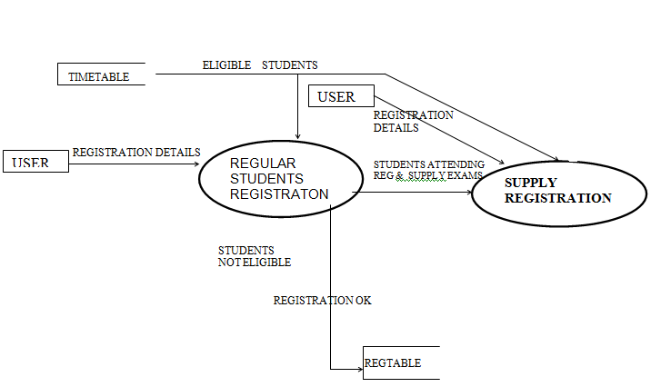

Figure 3.3: Activity Diagram

**3.4 Sequence Diagram**

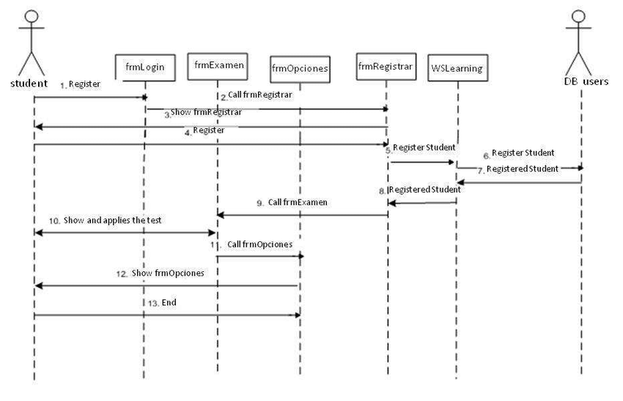

Figure 3.4: Sequence Diagram

## 3.5 ExamPro (Exam Cell Automation)

The students and the faculties will be registered first followed by the collection of information about the students and the respective faculty members along with the exam-cell staff members. The system will generate the schedule of exam time table and the blocks of exam hall.

The processes will be automated by implementing this system and the workload will be reduced to a great extent. In this system, input will be the schedule of exam of theory exams, practical exams, internal assessment and term work. Our system is divided into various modules 1. Login Module 2. Generation Registration Process 3. Generation of Exam Session 4. Generation of Admin Login.

### Module 1: Login

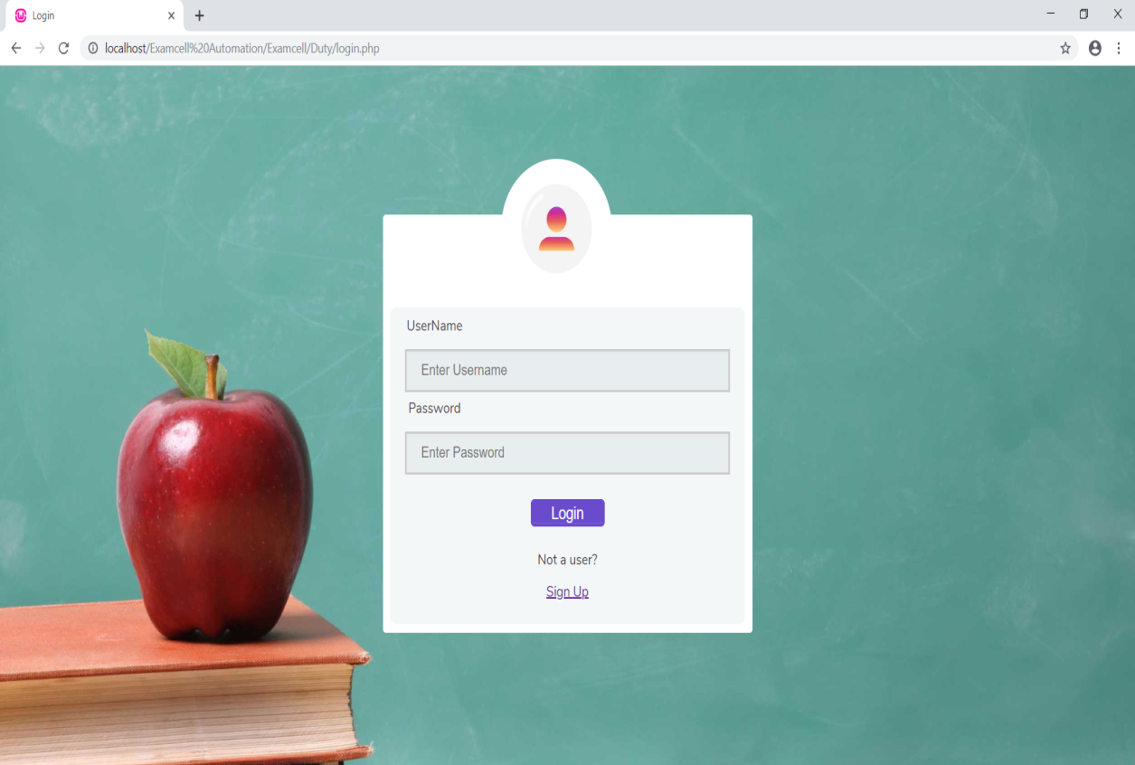

Figure 3.5: Login Page

### Module 2: Generation of Registration Process

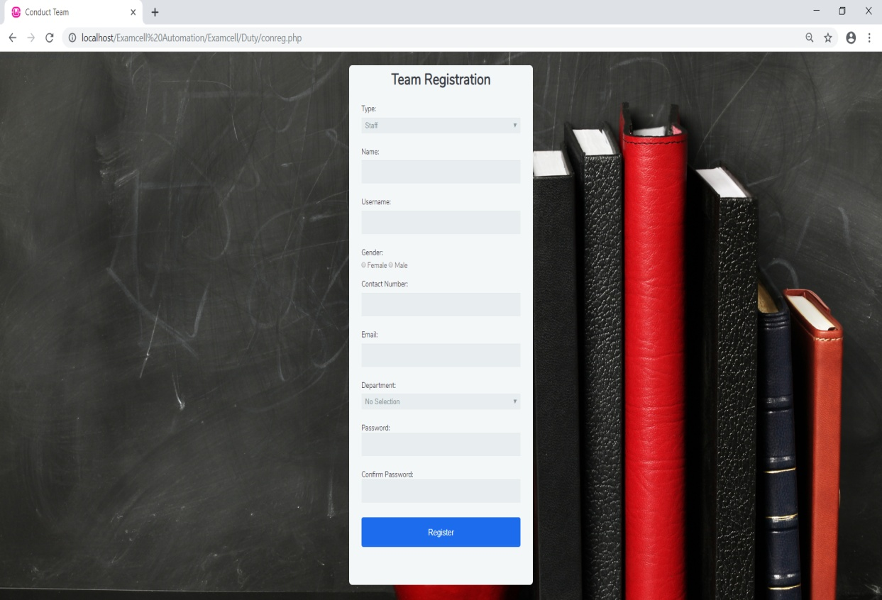

Figure 3.6: Registration Page

### Module 3: Generation of Exam Session

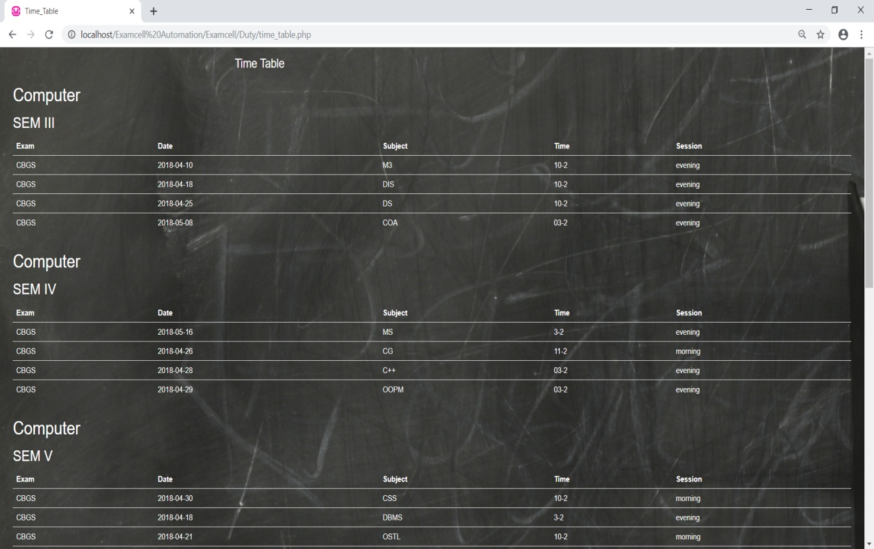

Figure 3.7: Exam Session Process

### Module 4: Admin Login

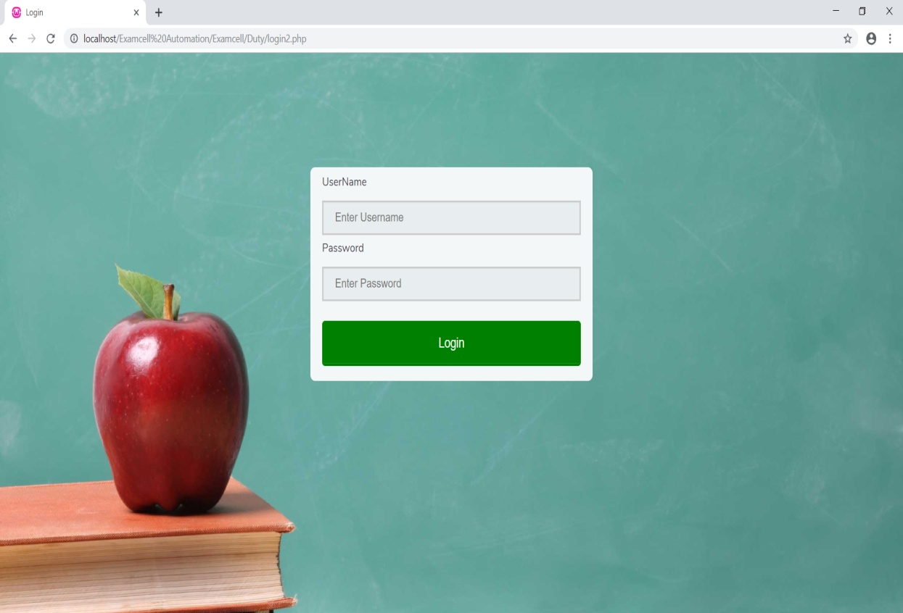

Figure 3.7: Admin Login Page

# 

# CHAPTER 4

# IMPLEMENTATION

**4.1 Code Snippets**

**#home.php**

<?php

session_start();

?>

<!DOCTYPE html>

<html lang="en">

<head>

<meta charset="utf-8">

<link rel="shortcut icon" href="img/favicon.png">

<title>EXAMCELL AUTOMATION</title>

<style type="text/css">

img{

display: block;

margin-left:auto;

margin-right: auto;

width: 60%;

padding-top: 200px;

padding-left: 100px;

}

img:hover {

/* Start the shake animation and make the animation last for 0.5 seconds */

animation: shake 0.5s;

/* When the animation is finished, start again */

animation-iteration-count: infinite;

}

@keyframes shake {

0% { transform: translate(1px, 1px) rotate(0deg); }

10% { transform: translate(-1px, -2px) rotate(-1deg); }

20% { transform: translate(-3px, 0px) rotate(1deg); }

30% { transform: translate(3px, 2px) rotate(0deg); }

40% { transform: translate(1px, -1px) rotate(1deg); }

50% { transform: translate(-1px, 2px) rotate(-1deg); }

60% { transform: translate(-3px, 1px) rotate(0deg); }

70% { transform: translate(3px, 1px) rotate(-1deg); }

80% { transform: translate(-1px, -1px) rotate(1deg); }

90% { transform: translate(1px, 2px) rotate(0deg); }

100% { transform: translate(1px, -2px) rotate(-1deg); }

}

</style>

<link href="csss/bootstrap.min.css" rel="stylesheet">

<link href="csss/bootstrap-theme.css" rel="stylesheet">

<link href="csss/elegant-icons-style.css" rel="stylesheet" />

<link href="csss/font-awesome.min.css" rel="stylesheet" />

<link href="csss/widgets.css" rel="stylesheet">

<link href="csss/style.css" rel="stylesheet">

<link href="csss/style-responsive.css" rel="stylesheet" />

<link href="csss/jquery-ui-1.10.4.min.css" rel="stylesheet">

<link rel="stylesheet" href="https://maxcdn.bootstrapcdn.com/bootstrap/3.3.7/css/bootstrap.min.css">

<script src="https://ajax.googleapis.com/ajax/libs/jquery/3.3.1/jquery.min.js"></script>

<script src="https://maxcdn.bootstrapcdn.com/bootstrap/3.3.7/js/bootstrap.min.js"></script>

</head>

<body>

<section id="container" class="">

<header class="header dark-bg">

<a href="#" class="logo">EXAMCELL <span class="lite">AUTOMATION</span></a>

<div class="top-nav notification-row">

<ul class="nav navbar-nav navbar-right">

<li><a href="logout.php"><span class="glyphicon glyphicon-log-out"></span> Logout</a></li>

</ul>

</header>

<aside>

<div id="sidebar" class="nav-collapse ">

<ul class="sidebar-menu">

<li><a class="" href="time_table.php">

<i class="icon_table"></i>

<span>Time Table</span></a></li>

<li><a class="" href="duty_ass.php">

<i class="icon_table"></i>

<span>Duty Assigned</span></a></li>

<li><a class="" href="dutyc.php">

<i class="icon_table"></i>

<span>Duty Chart</span></a></li>

</ul>

</div>

</aside>

</section>

<img src="img/a.jpg">

</body>

</html>

**#index.php**

<?php

session_start();

?>

<!DOCTYPE html>

<head>

<meta http-equiv="Content-Type" content="text/html; charset=utf-8" />

<title>EXAMCELL AUTOMATION</title>

<link rel="stylesheet" href="css2/bootstrap.min.css">

<link rel="stylesheet" href="css2/bootstrap-theme.min.css">

<link href="css2/style.css" rel="stylesheet" type="text/css" />

<script src="js/bootstrap.min.js"></script>

<style type="text/css">

body{

background-image: url(img/gh.jpg);

}

</style>

</head>

<body>

<div class="content">

<div class="header">

<div class="container-fluid">

<div class="row">

<div class="col-xs-12 col-sm-6 col-md-4 col-lg-4"> </div>

<div class="col-xs-12 col-sm-6 col-md-8 col-lg-8">

<nav class="main_menu">

<ul>

<li class="active"><a href="about.php">About us</a></li>

<li><a href="login2.php">Admin login</a></li>

<li><a href="login.php">Sign in</a></li>

</ul>

</nav>

</div>

</div>

</div>

</div>

<div class="clearfix"></div>

<div class="page_content">

<div class="container-fluid">

<div class="row">

<div class="hidden-xs col-sm-1 col-md-2 col-lg-2"> </div>

<div class="col-xs-12 col-sm-10 col-md-8 col-lg-8">

<form action="generate.php?step=1" method="post" enctype="application/x-www-form-urlencoded">

</div>

</div>

<center>

</center>

</form>

</div>

<div class="hidden-xs col-sm-1 col-md-2 col-lg-2"> </div>

</div>

</div>

</div>

</div>

<footer>

<div class="container-fluid">

<div class="row-fluid">

<div class="col-md-6">

<ul>

</div>

<div class="col-md-6 text-right copyright"> Developed by <a href="#">Department of TECO</a> </div>

</div>

</div>

</footer>

</body>

</html>

**#index2.php**

<?php

session_start();

?>

<!DOCTYPE html>

<head>

<meta http-equiv="Content-Type" content="text/html; charset=utf-8" />

<title>EXAMCELL AUTOMATION</title>

<link rel="stylesheet" href="css2/bootstrap.min.css">

<link rel="stylesheet" href="css2/bootstrap-theme.min.css">

<link href="css2/style.css" rel="stylesheet" type="text/css" />

<script src="js/bootstrap.min.js"></script>

<style type="text/css">

body{

background-image: url(img/gh.jpg);

}

</style>

</head>

<body>

<div class="content">

<div class="header">

<div class="container-fluid">

<div class="row">

<div class="col-xs-12 col-sm-6 col-md-4 col-lg-4"> </div>

<div class="col-xs-12 col-sm-6 col-md-8 col-lg-8">

<nav class="main_menu">

<ul>

<li class="active"><a href="index.php">Home<br></a></li>

<li class="active"><a href="timtab.php">Update TT</a></li>

<li><a href="asag.php">Update Duties</a></li>

<li><a href="dutys.php">Update DC</a></li>

<li><a href="timtab.php">Update TT</a></li>

<li><a href="logout2.php">Logout</a></li>

</ul>

</nav>

</div>

</div>

</div>

</div>

<div class="clearfix"></div>

<div class="page_content">

<div class="container-fluid">

<div class="row">

<div class="hidden-xs col-sm-1 col-md-2 col-lg-2"> </div>

<div class="col-xs-12 col-sm-10 col-md-8 col-lg-8">

<form action="generate.php?step=1" method="post" enctype="application/x-www-form-urlencoded">

</div>

</div>

<center>

</center>

</form>

</div>

<div class="hidden-xs col-sm-1 col-md-2 col-lg-2"> </div>

</div>

</div>

</div>

</div>

<footer>

<div class="container-fluid">

<div class="row-fluid">

<div class="col-md-6">

<ul>

</div>

<div class="col-md-6 text-right copyright"> Developed by <a href="#">Department of TECO</a> </div>

</div>

</div>

</footer>

</body>

</html>

**#login.php**

<!DOCTYPE html>

<html lang="en" >

<head>

<meta charset="UTF-8">

<title>Login</title>

<link rel="stylesheet" href="https://cdnjs.cloudflare.com/ajax/libs/normalize/5.0.0/normalize.min.css">

<link rel="stylesheet" href="css/style.css">

<meta name="viewport" content="width=device-width, initial-scale=1.0">

<script src="https://ajax.googleapis.com/ajax/libs/jquery/3.2.1/jquery.min.js"></script>

<link rel="stylesheet" href="css/normalize.css">

<link href='https://fonts.googleapis.com/css?family=Nunito:400,300' rel='stylesheet' type='text/css'>

<link rel="stylesheet" href="css/main.css">

<style type="text/css">

body{

background-image: url(2.jpg);

background-size: cover;

}

.container{

width: 500px;

height: 450px;

text-align: center;

margin: 0 auto;

background-color: white;

border-radius: 4px;

margin-top:160px;

}

.container img{

width: 150px;

height: 150px;

margin-top: -60px;

margin-right: 30px;

vertical-align: middle;

border-radius: 50%;

}

.container .avatar img{

position: absolute;

left: (50%-50px);

top: -50px;

}

input[type=text], input[type=password] {

max-height:250px;

width: 100%;

padding: 12px 20px;

margin: 8px 0;

display: inline-block;

border: 2px solid #ccc;

box-sizing: border-box;

}

button{

background-color: #6a4acd;

border-color: #6a4acd;

padding:5px 7px;

height: 30px;

width: 100px;

}

button:hover {

opacity: 0.9;

display: inline-block;

}

.req{

padding-right: 360px;

}

</style>

</head>

<body>

<?php

//Printing Invalid input

if(isset($_GET['error']))

echo '<div class="alert alert-warning"><a href="#" class="close" data-dismiss="alert" aria-label="close">&times;</a><b>Oops..!</b> Authentication error..! Please check your username and password. <style="color:blue;text-align=center></style></div>';

?>

<div class="container">

<img src="user.png" class="avatar">

<form method="POST" action="login_action.php" >

<div class="form-input">

<label for="user_name" class="req">UserName</label>

<input id="user_name" placeholder="Enter Username" type="text" name="user_name">

<label for="password" class="req">Password</label>

<input type="password" name="password" placeholder="Enter Password" >

<br><br>

</div>

<div>

<button type="submit" name="login_user" >Login</button>

<p>Not a user?</p><a href="conreg.php">Sign Up</a>

</p>

</div>

</form>

</div>

</body>

</html>

**#login2.php**

<!DOCTYPE html>

<html lang="en" >

<head>

<meta charset="UTF-8">

<title>Login</title>

<link rel="stylesheet" href="https://cdnjs.cloudflare.com/ajax/libs/normalize/5.0.0/normalize.min.css">

<link rel="stylesheet" href="css/style.css">

<meta name="viewport" content="width=device-width, initial-scale=1.0">

<script src="https://ajax.googleapis.com/ajax/libs/jquery/3.2.1/jquery.min.js"></script>

<link rel="stylesheet" href="css/normalize.css">

<link href='https://fonts.googleapis.com/css?family=Nunito:400,300' rel='stylesheet' type='text/css'>

<link rel="stylesheet" href="css/main.css">

<style type="text/css">

body{

background-image: url(2.jpg);

background-size: cover;

}

form{

margin-top: 10%;

}

a:hover{

text-shadow :1px 1px #b72ca2;

}

button{

background-color: green;

border-color: green;

}

input[type=text], input[type=password] {

max-height:250px;

width: 100%;

padding: 12px 20px;

margin: 8px 0;

display: inline-block;

border: 2px solid #ccc;

box-sizing: border-box;

}

.req{

padding-right: 360px;

}

</style>

</head>

<body>

<?php

if(isset($_GET['error']))

echo'<div class="alert alert-warning"><a href="#" class="close" data-dismiss="alert" aria-label="close">&times;</a><b>Oops..!</b> Authentication error..! Please check your username and password. <style="color:blue;text-align:center"></div>';

?>

<form method="POST" action="log.php" >

<div class="form-input">

<label for="user_name" class="req">UserName</label>

<input id="user_name" placeholder="Enter Username" type="text" name="user_name">

<label for="password" class="req">Password</label>

<input type="password" name="password" placeholder="Enter Password" >

<br><br>

</div>

<div>

<button type="submit" name="login_user" >Login</button>

</div>

</form>

</body>

</html>

**#conreg.php**

<?php include('conb.php') ?>

//header('location:login.php');

<!DOCTYPE html>

<html>

<head>

<meta charset="UTF-8">

<title>Conduct Team</title>

<link rel="stylesheet" href="https://cdnjs.cloudflare.com/ajax/libs/normalize/5.0.0/normalize.min.css">

<link rel="stylesheet" href="css/style.css">

<meta name="viewport" content="width=device-width, initial-scale=1.0">

<script src="https://ajax.googleapis.com/ajax/libs/jquery/3.2.1/jquery.min.js"></script>

<link rel="stylesheet" href="css/normalize.css">

<link href='https://fonts.googleapis.com/css?family=Nunito:400,300' rel='stylesheet' type='text/css'>

<link rel="stylesheet" href="css/main.css">

<Style>

body{

background-image:url("3.jpg");

background-size: cover;

}

button{

background-color: #1c6ced;

border-color: #1c6ced;

}

</Style>

</head>

<body>

<form action="regb.php" method="POST">

<h1>Team Registration</h1>

<fieldset>

<label for="type" class="req">Type:</label>

<select id="typ" name="type" onclick="Select()">

<ul class="dropdown-menu">

<li>

<option>Staff</option>

<option>Examcell</option>

<option>Conduction Cell</option>

</li>

</ul>

</select>

<br>

<label for="name" class="req">Name:</label>

<input type="text" id="name" name="name">

<label for="name" class="req">Username:</label>

<input type="text" id="user" name="user_name">

<label>Gender:</label>

<input type="radio" id="female" value="female" name="gender"><label for="gender" class="light">Female</label>

<input type="radio" id="male" value="male" name="gender"><label for="gender" class="light">Male</label>

<br></br>

<label for="contact_no" class="req">Contact Number:</label>

<input type="text" id="contact_no" name="contact" >

<label for="mail">Email:<span class="req"></label>

<input type="email" id="mail" name="email">

<label for="post" id="pst" style="display: none;">Post:<span class="req"></label>

<input type="text" id="pst1" style="display: none;" name="post">

<LABEL id="sel1" style='display: block'>Department:</LABEL>

<select style="display:block" id="sel" name='department'>

<option>No Selection</option>

<option>Computer</option>

</select>

<label for="pwd">Password:<span class="req">

<input type="password" id="pwd" name="password_1">

<label for="confirmpwd">Confirm Password:<span class="req">

<input type="password" id="copwd" name="password_2" >

<button type="submit" name="reg_user">Register</button>

<p>

<?php include("error.php") ?>

</fieldset>

</body>

</html>

**#time_table.php**

<?php

include("style.php");

$db = mysqli_connect('localhost','root','','duty');

#COMPUTER

$result3 = mysqli_query($db,"select exam,date,subject,session,time from time_table where department='Computer' and sem='III'");

$result4 = mysqli_query($db,"select exam,date,subject,session,time from time_table where department='Computer' and sem='IV'");

$result5 = mysqli_query($db,"select exam,date,subject,session,time from time_table where department='Computer' and sem='V'");

$result6 = mysqli_query($db,"select exam,date,subject,session,time from time_table where department='Computer' and sem='VI'");

$result7 = mysqli_query($db,"select exam,date,subject,session,time from time_table where department='Computer' and sem='VII'");

$result8 = mysqli_query($db,"select exam,date,subject,session,time from time_table where department='Computer' and sem='VIII'");

?>

<!DOCTYPE html>

<html>

<head>

<title>Time_Table</title>

<meta charset="utf-8">

<meta name="viewport" content="width=device-width, initial-scale=1">

<link rel="stylesheet" href="https://maxcdn.bootstrapcdn.com/bootstrap/3.3.7/css/bootstrap.min.css">

<script src="https://ajax.googleapis.com/ajax/libs/jquery/3.3.1/jquery.min.js"></script>

<script src="https://maxcdn.bootstrapcdn.com/bootstrap/3.3.7/js/bootstrap.min.js"></script>

<style type="text/css">

h3{

margin-left: 550px;

color: white;

}

h1,h2,th{

color: white;

}

</style>

</head>

<body>

<fieldset>

<form action="" method="POST">

<h3>Time Table</h3>

<div class="container-fluid">

<!-- COMPUTER-->

<div class="container-fluid">

<h1>Computer</h1>

<h2>SEM III</h2>

<table class="table">

<div class="col-sm-3">

<thead>

<tr>

<th>Exam</th>

<th>Date</th>

<th>Subject</th>

<th>Time</th>

<th>Session</th>

</tr>

</thead>

<tbody>

<?php while($row= mysqli_fetch_array($result3)){?>

<tr>

<td style="color: white;"><?php echo $row['exam']; ?></td>

<td style="color: white;"><?php echo $row['date']; ?></td>

<td style="color: white;"><?php echo $row['subject']; ?></td>

<td style="color: white;"><?php echo $row['time']; ?></td>

<td style="color: white;"><?php echo $row['session']; ?></td>

</tr>

<?php } ?>

</tbody>

</div>

</table>

</div>

<div class="container-fluid">

<h1>Computer</h1>

<h2>SEM IV</h2>

<table class="table">

<div class="col-sm-3">

<thead>

<tr>

<th>Exam</th>

<th>Date</th>

<th>Subject</th>

<th>Time</th>

<th>Session</th>

</tr>

</thead>

<tbody>

<?php while($row= mysqli_fetch_array($result4)){?>

<tr>

<td style="color: white;"><?php echo $row['exam']; ?></td>

<td style="color: white;"><?php echo $row['date']; ?></td>

<td style="color: white;"><?php echo $row['subject']; ?></td>

<td style="color: white;"><?php echo $row['time']; ?></td>

<td style="color: white;"><?php echo $row['session']; ?></td>

</tr>

<?php } ?>

</tbody>

</div>

</table>

</div>

<div class="container-fluid">

<h1>Computer</h1>

<h2>SEM V</h2>

<table class="table">

<div class="col-sm-3">

<thead>

<tr>

<th>Exam</th>

<th>Date</th>

<th>Subject</th>

<th>Time</th>

<th>Session</th>

</tr>

</thead>

<tbody>

<?php while($row= mysqli_fetch_array($result5)){?>

<tr>

<td style="color: white;"><?php echo $row['exam']; ?></td>

<td style="color: white;"><?php echo $row['date']; ?></td>

<td style="color: white;"><?php echo $row['subject']; ?></td>

<td style="color: white;"><?php echo $row['time']; ?></td>

<td style="color: white;"><?php echo $row['session']; ?></td>

</tr>

<?php } ?>

</tbody>

</div>

</table>

</div>

<div class="container-fluid">

<h1>Computer</h1>

<h2>SEM VI</h2>

<table class="table">

<div class="col-sm-3">

<thead>

<tr>

<th>Exam</th>

<th>Date</th>

<th>Subject</th>

<th>Time</th>

<th>Session</th>

</tr>

</thead>

<tbody>

<?php while($row= mysqli_fetch_array($result6)){?>

<tr>

<td style="color: white;"><?php echo $row['exam']; ?></td>

<td style="color: white;"><?php echo $row['date']; ?></td>

<td style="color: white;"><?php echo $row['subject']; ?></td>

<td style="color: white;"><?php echo $row['time']; ?></td>

<td style="color: white;"><?php echo $row['session']; ?></td>

</tr>

<?php } ?>

</tbody>

</div>

</table>

</div>

<div class="container-fluid">

<h1>Computer</h1>

<h2>SEM VII</h2>

<table class="table">

<div class="col-sm-3">

<thead>

<tr>

<th>Exam</th>

<th>Date</th>

<th>Subject</th>

<th>Time</th>

<th>Session</th>

</tr>

</thead>

<tbody>

<?php while($row= mysqli_fetch_array($result7)){?>

<tr>

<td style="color: white;"><?php echo $row['exam']; ?></td>

<td style="color: white;"><?php echo $row['date']; ?></td>

<td style="color: white;"><?php echo $row['subject']; ?></td>

<td style="color: white;"><?php echo $row['time']; ?></td>

<td style="color: white;"><?php echo $row['session']; ?></td>

</tr>

<?php } ?>

</tbody>

</div>

</table>

</div>

<div class="container-fluid">

<h1>Computer</h1>

<h2>SEM VIII</h2>

<table class="table">

<div class="col-sm-3">

<thead>

<tr>

<th>Exam</th>

<th>Date</th>

<th>Subject</th>

<th>Time</th>

<th>Session</th>

</tr>

</thead>

<tbody>

<?php while($row= mysqli_fetch_array($result8)){?>

<tr>

<td style="color: white;"><?php echo $row['exam']; ?></td>

<td style="color: white;"><?php echo $row['date']; ?></td>

<td style="color: white;"><?php echo $row['subject']; ?></td>

<td style="color: white;"><?php echo $row['time']; ?></td>

<td style="color: white;"><?php echo $row['session']; ?></td>

</tr>

<?php } ?>

</tbody>

</div>

</table>

</div>

**#Duty_Assigned.php**

<?php

session_start();

include("style.php");

$db = mysqli_connect("localhost", "root", "","duty");

$result = mysqli_query($db,"select * from faculty where type='Teaching'");

$remark="";

?>

<!DOCTYPE html>

<html>

<head>

<title>Time_Table</title>

<meta charset="utf-8">

<meta name="viewport" content="width=device-width, initial-scale=1">

<link rel="stylesheet" href="https://maxcdn.bootstrapcdn.com/bootstrap/3.3.7/css/bootstrap.min.css">

<script src="https://ajax.googleapis.com/ajax/libs/jquery/3.3.1/jquery.min.js"></script>

<script src="https://maxcdn.bootstrapcdn.com/bootstrap/3.3.7/js/bootstrap.min.js"></script>

</head>

<body>

<fieldset>

<form action="Duties_Assigned.php" method="POST">

<div class="container-fluid">

<h1>Duty Assigned:</h1>

<table class="table">

<div class="col-sm-3">

<thead>

<tr>

<th>Staff Name</th>

<th>No_of_duties</th>

<th>Remark</th>

</tr>

</thead>

<tbody>

<?php

while ($row = mysqli_fetch_array($result))

{

if($row['post']=='HOD')

{

$no_of_duties=0;

}

elseif($row['post']=='Assistant Professor')

{

$no_of_duties=3;

}

elseif($row['post']=='Associate Professor')

{

$no_of_duties='4';

}

elseif($row['post']=='Professor')

{

$no_of_duties='5';

}

else

{

$no_of_duties='NULL';

}

echo "<tr> <td>".$row['name']."</td><td>".$no_of_duties."</td> <td>".$row['post']."</td></tr>";

// echo $row['name'];

// echo "";

// // echo $array['no_of_duties'];

// echo "</td> <td>";

// echo ;

// echo "</td></tr>";

}

?>

</tbody>

</div>

</table>

</form>

</fieldset>

</body>

</html>

**4.2 Screen Shots**

**#home.php**

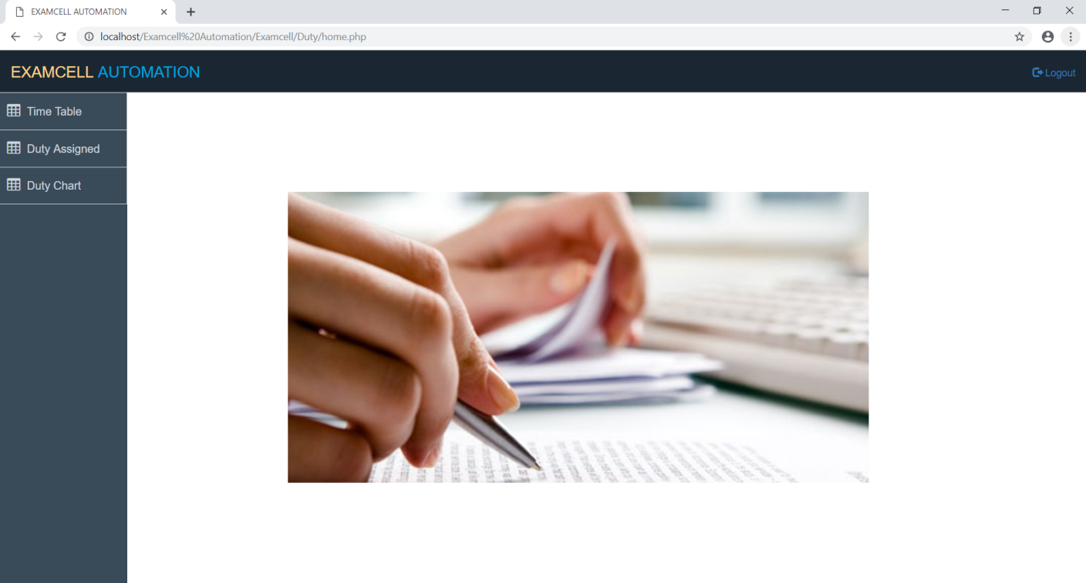

**#index.php**

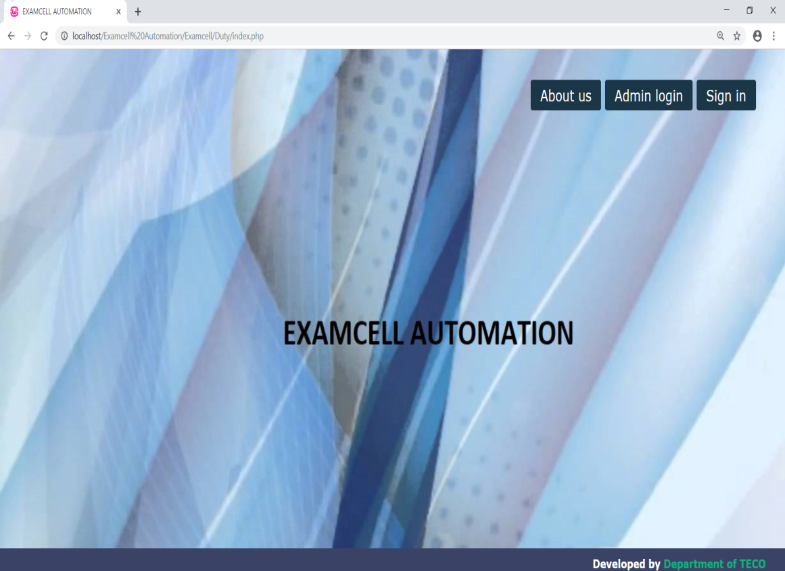

**#index2.php**

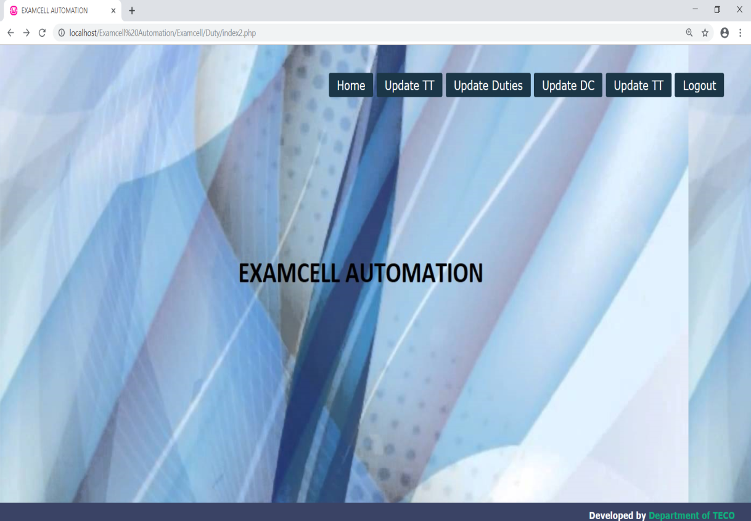

**#login.php**

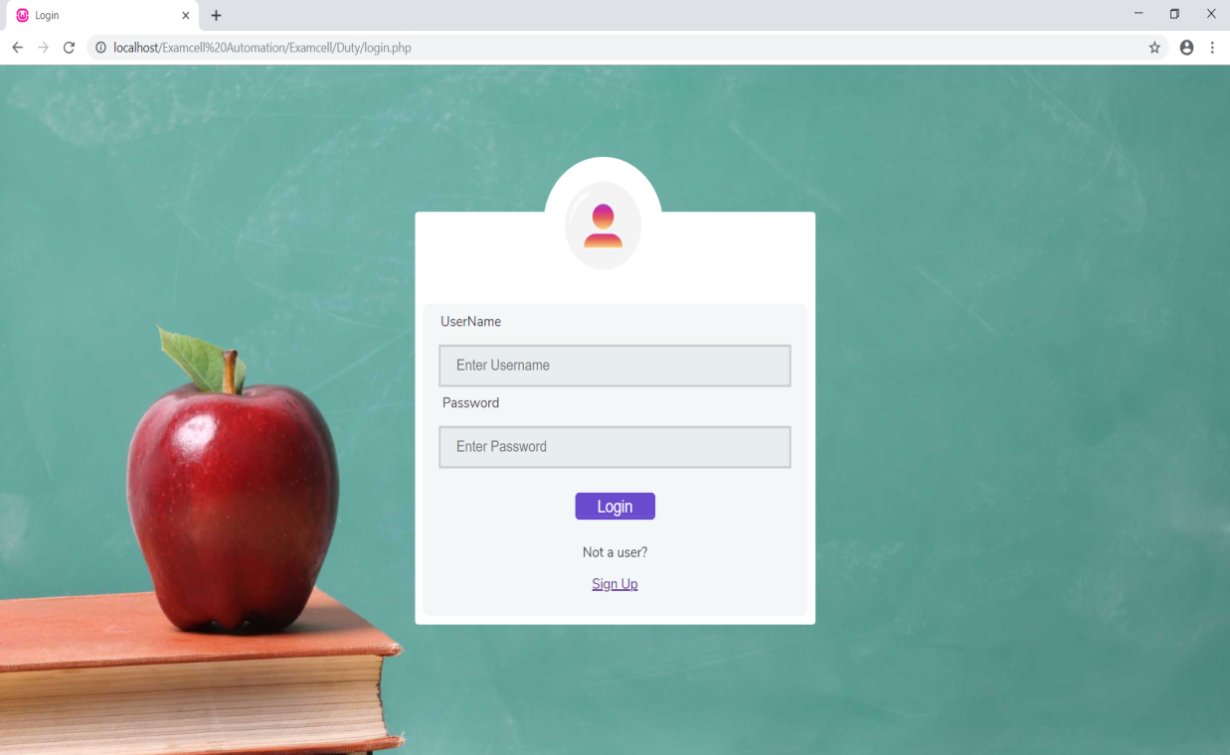

**#login2.php**

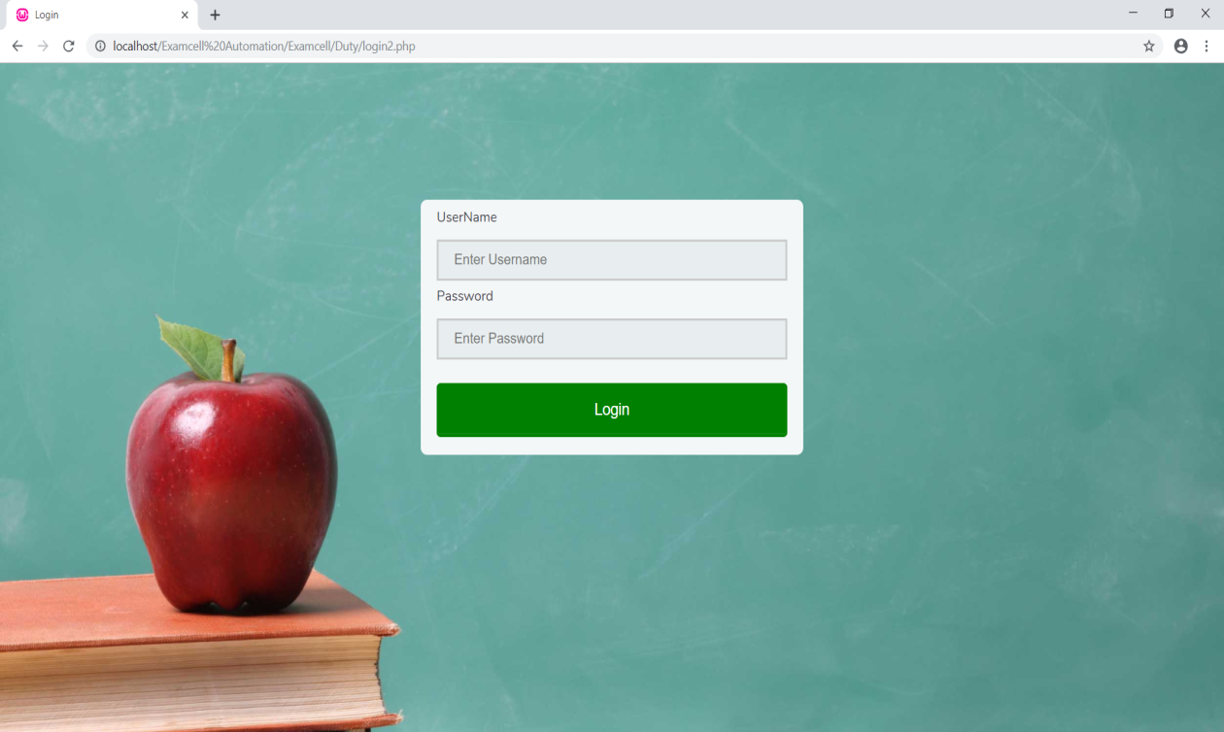

**#congreg.php**

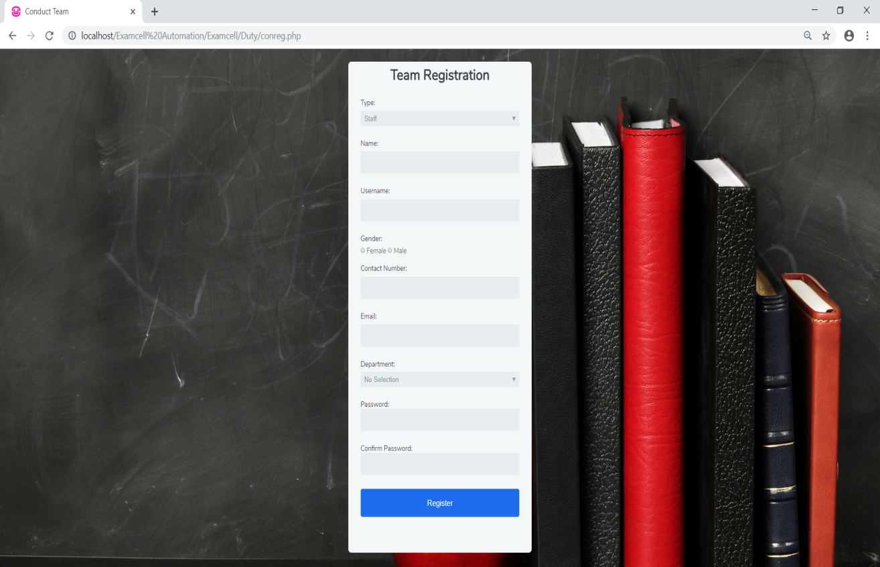

**#time_table.php**

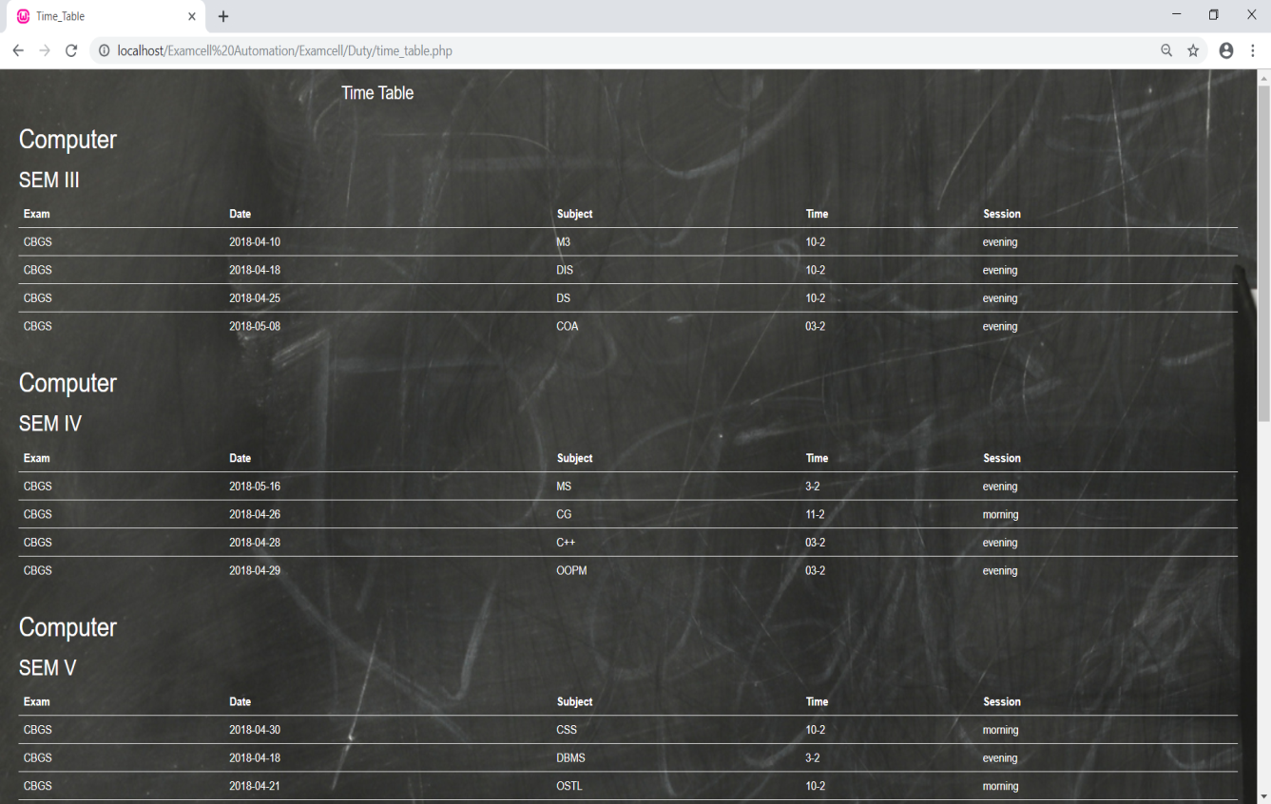

**#Duty_Assigned.php**

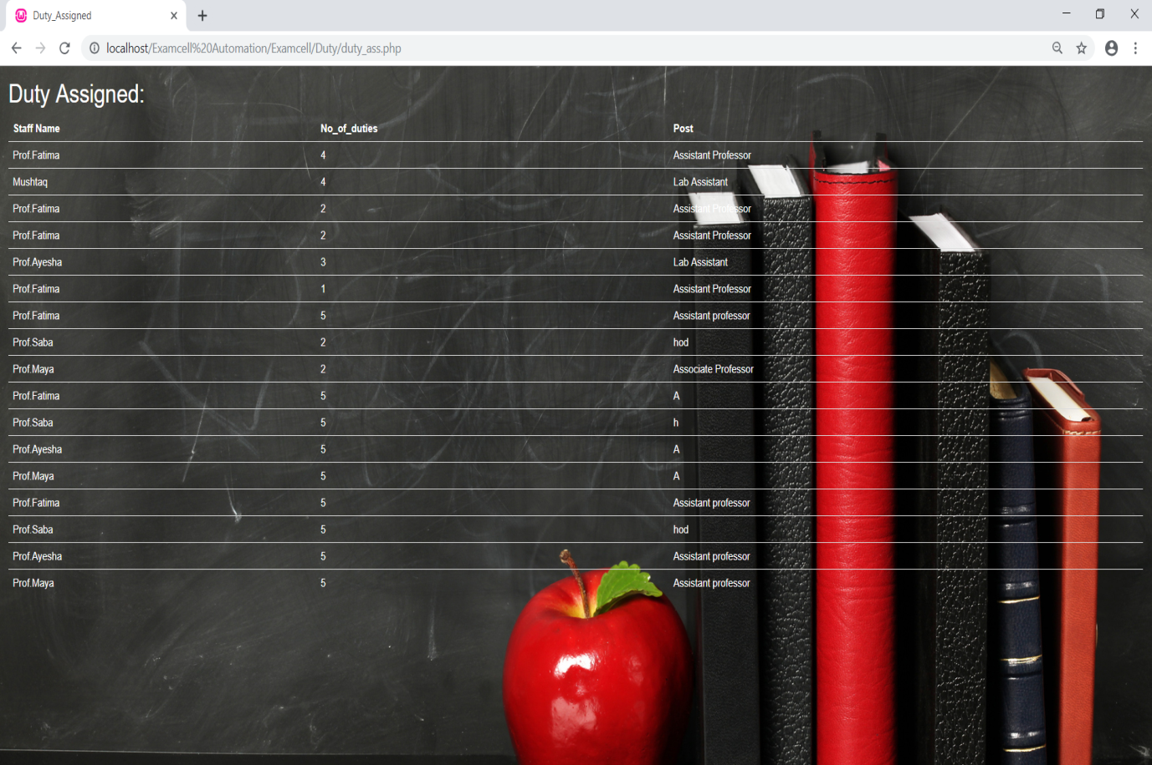

# Chapter 5

# CONCLUSION

## Conclusion

Ultimately the result of the implementation of this project will lead to reduce the workload of the students, the faculty members and the exam-cell staff. The result would be a fully-fledged working Automated Examination Process System.

The Head of the department will be able to monitor the status of the students as well the marks verification and validation for the students will be done by the head of department. There won’t be any need to use multiple different systems for different activities. The processes will be covered by the proposed system. This will reduce the tediousness of the manual processes and give a chance for efficient, flexible and automated processes.

## Limitations

For now, the system is limited to a single department of an engineering institute. The system will not work if the internet connection is down.

## Future Scope

As the technologies are emerging, it is possible to enhance the system and make it adaptable to desired environment i.e. customize as per the college requirements. Using which, the examination schedule, databases could be digitalized saving a lot of space and providing faster access.

As per the requirements of the College, further changes could be implemented in the system making it more reliable, more efficient and convenient for everybody to use it.

# References

1. XamClick Exam Cell Automation System by Harsha Khutafale, Hardika Mate, Vaishnavi Sabnawis, Prof. Nilesh Patil, International Journal of Advanced Research in Computer Science and Software Engineering-2016
2. Exam-Cell Automation System: Nevonprojects.com
3. Automated Examination Support System by Bondre Rutuja Avinash, Durgi Varsha Vijayku- mar, Mohite Pradnesh Rajeev, Parkar Vishal V, International Journal of Current Engineering and Technology-2015
4. KHUSHI: Exam Cell Automation System
5. Sanket Mandare, Tyagraj Sonawane, Aman Trivedi, K. T. V. Reddy *PDF Marksheet Gener- ator: I.J. Information Technology and Computer Science, 2014*
6. Somdip Dey *New Generation of Digital Academic-Transcripts using encrypted QR Code: IEEE*
7. Prof. D. V. Shinkar *QR code Authentication System for confidential(digital Mark sheet) Encrypted data hiding and retrieval (Decryption): International Journal of Advanced Research in Computer and Communication Engineering*
8. Trisha Chatterjee, Tamodeep Das, Joyshree Nath, Shayan Dey, AsokeNath *Symmetric key cryptosystem using combined cryptographicalgorithms - Generalized modified Vernam Cipher method, MSAmethod and NJJSAA method: TTJSA algorithmâ: Proceedings of Information and Communication Technologies (WICT)*
9. Suraj Kumar Sahu, Sandeep Kumar Gonnade *QR Code and Application in India: Interna- tional Journal of Recent Technology and Engineering (IJRTE)*
10. John Enderle, Nicholas Noyes, Abdullah A. AlAqeel *Custom report generator: IEEE 26th Annual Bioengineering Conference,2000*

# ACKNOWLEDGMENT

We would like to take the opportunity to express our sincere thanks to our guide **Rehaal Qureshi**, Professor, Department of Computer Engineering, AIKTC, School of Engineering, Panvel for his invaluable support and guidance throughout our project research work. Without his kind guidance & support this was not possible.

We are grateful to him for his timely feedback which helped us track and schedule the process effec- tively. His time, ideas and encouragement that he gave helped us to complete our project efficiently. We would also like to thank **Dr. Abdul Razak Honnutagi**, AIKTC, Panvel, for his encouragement and for providing an outstanding academic environment, also for providing the adequate facilities. We are thankful to **Prof. Tabrez Khan**, HOD, Department of Computer Engineering, AIKTC, School of Engineering, Panvel and all my B.E. teachers for providing advice and valuable guidance. We also extend our sincere thanks to all the faculty members and the non-teaching staff and friends for their cooperation.

Last but not the least, we are thankful to all our family members whose constant support and encourage- ment in every aspect helped us to complete our project.

**Khan Yaman Mirde Amrin**

Roll No: 15CO05 Roll No: 16CO05

**Ansari Faisal**

Roll No: 17DCO62